**Fly Away**

**(An Airline Booking Portal)**

* **Content**

1. Project and Developer Details
2. Sprints Planned and the Tasks Achieved in them
3. Algorithms and Flowcharts of the Application
4. Core Concepts Used in the Project
5. Functionality & Features of Locker Project
6. Links to the GitHub Repository
7. Your conclusion on enhancing the application and defining the USPs

**1. Project and Developer Details**

**Project Objective ->**

* As a Full Stack Developer, design and develop an airline booking portal named as Fly Away. Use the GitHub repository to manage the project artifacts.

**Application Features ->**

* After running of application on server, User/Admin will be redirected to Home Page.
* On Home Page, there are two options either login as User or Admin.

1. If logged in as **User** – User can search for flights
   * Fill the criteria for search of flight and submit.
   * List of all available flights matching your criteria will be displayed.
   * User can click on book now to book his seat for that flight.
   * If payment is success and booking is done, user will get success message with his flight id.
   * Else user will get booking failure message.
2. If logged in as **Admin** – Admin can search flights and add new flights.
3. Search Flight
   1. Fill the criteria for search of flight and submit.
   2. List of all available flights matching your criteria will be displayed.
   3. Admin can click on book now to book his seat for that flight or he can click on delete flight to delete that flight from database.
   4. In case of booking, if payment is success and booking is done, admin will get success message with his flight id.
   5. Else admin will get booking failure message.
4. Add New Flight
   1. Admin has to fill all the required details of the new flight.
   2. On clicking of submit, flight will be added to database.
5. View All Available Flights
6. Admin can click on View All Available Flights link on Home page and all the available flights will be displayed.
7. Delete Flights
8. Admin can delete flights by checking on View all available flights and selecting delete option for respective flight.

**Developer Details ->**

1. **Name :** Shreyash Vijay Pawar
2. **Designation :** Developer
3. **IDE used :** Eclipse & VS Code
4. **Server Used :** Tomcat
5. **Database Used :** SQL(Oracle)
6. **Framework for DB Connection :** Hibernate 5.4

**2. Sprints Planned and the Tasks Achieved in them**

|  |  |  |  |  |  |  |
| --- | --- | --- | --- | --- | --- | --- |
| Sprint | Task | Developer | Estimated Time (Hrs) | Actual Time (Hrs) | Remaining Time (Hrs) | Status |
| #1 | Analysis Finished | Shreyash | 1 | 1 | 0 | Complete |
| UI for Application | Shreyash | 3 | 3 | 0 | Complete |
| Login/Log Out Functionality | Shreyash | 3 | 3 | 0 | Complete |
| Create New User/Password Reset | Shreyash | 3 | 3 | 0 | Complete |
| #2 | Search Flight & Flight Booking | Shreyash | 3 | 3 | 0 | Complete |
| Add Flight & Delete Flight | Shreyash | 3 | 3 | 0 | Complete |
| View All Locations & Session Management | Shreyash | 2 | 2 | 0 | Complete |
| Documentation | Shreyash | 2 | 2 | 0 | Complete |

**3. Algorithms and Flowcharts of the Application**

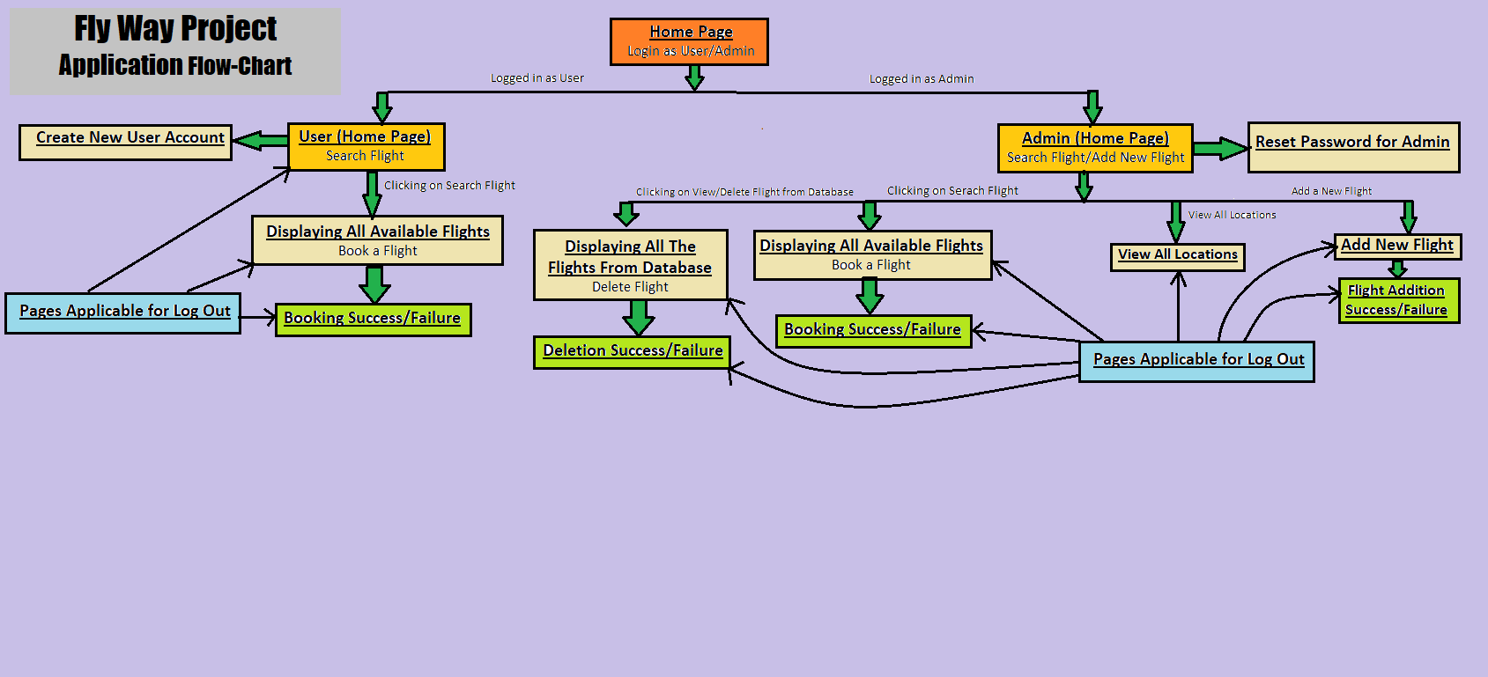

**4. Core Concepts Used in the Project**

1. Java 8 & Above
2. Servlets
3. Annotation
4. Hibernate
5. SQL
6. JSP
7. Maven
8. MVC Model
9. Session Handling

**5. Functionality & Features of Locker Project**

**Home Page for Web Application**

**URL:** <http://localhost:8080/FlyAway/>

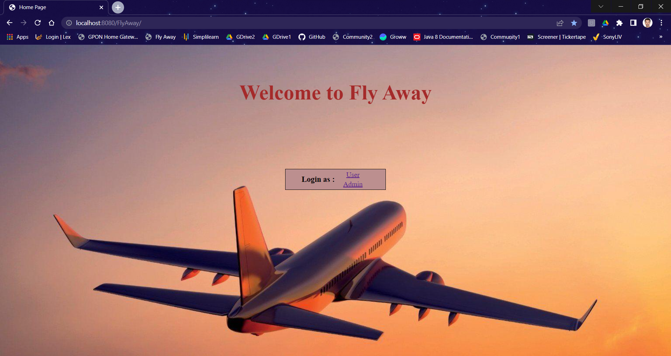

1. **Login as User**

**URL:** <http://localhost:8080/FlyAway/UserLogin.jsp>

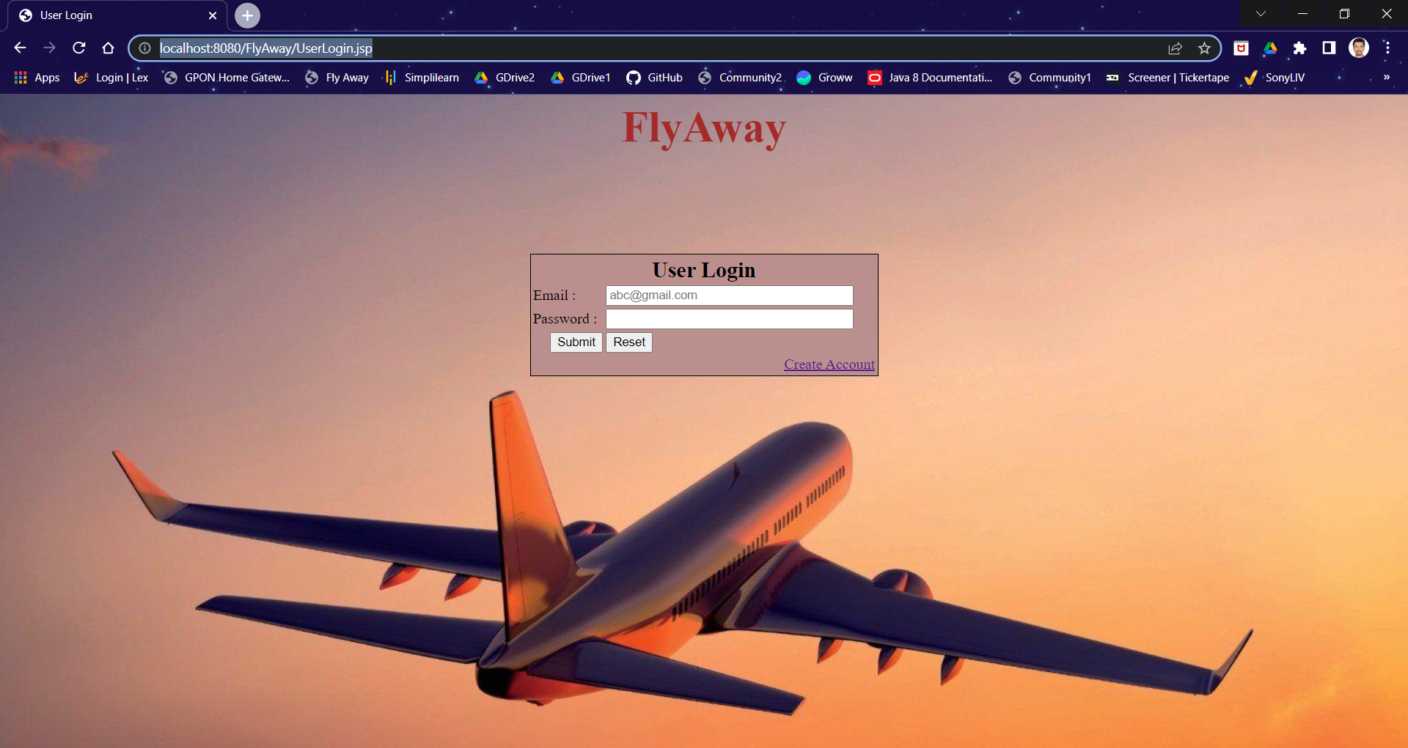

1. **Account Creation Functionality**

**URL:** <http://localhost:8080/FlyAway/CreateAccount.jsp>

**Create Account Page**

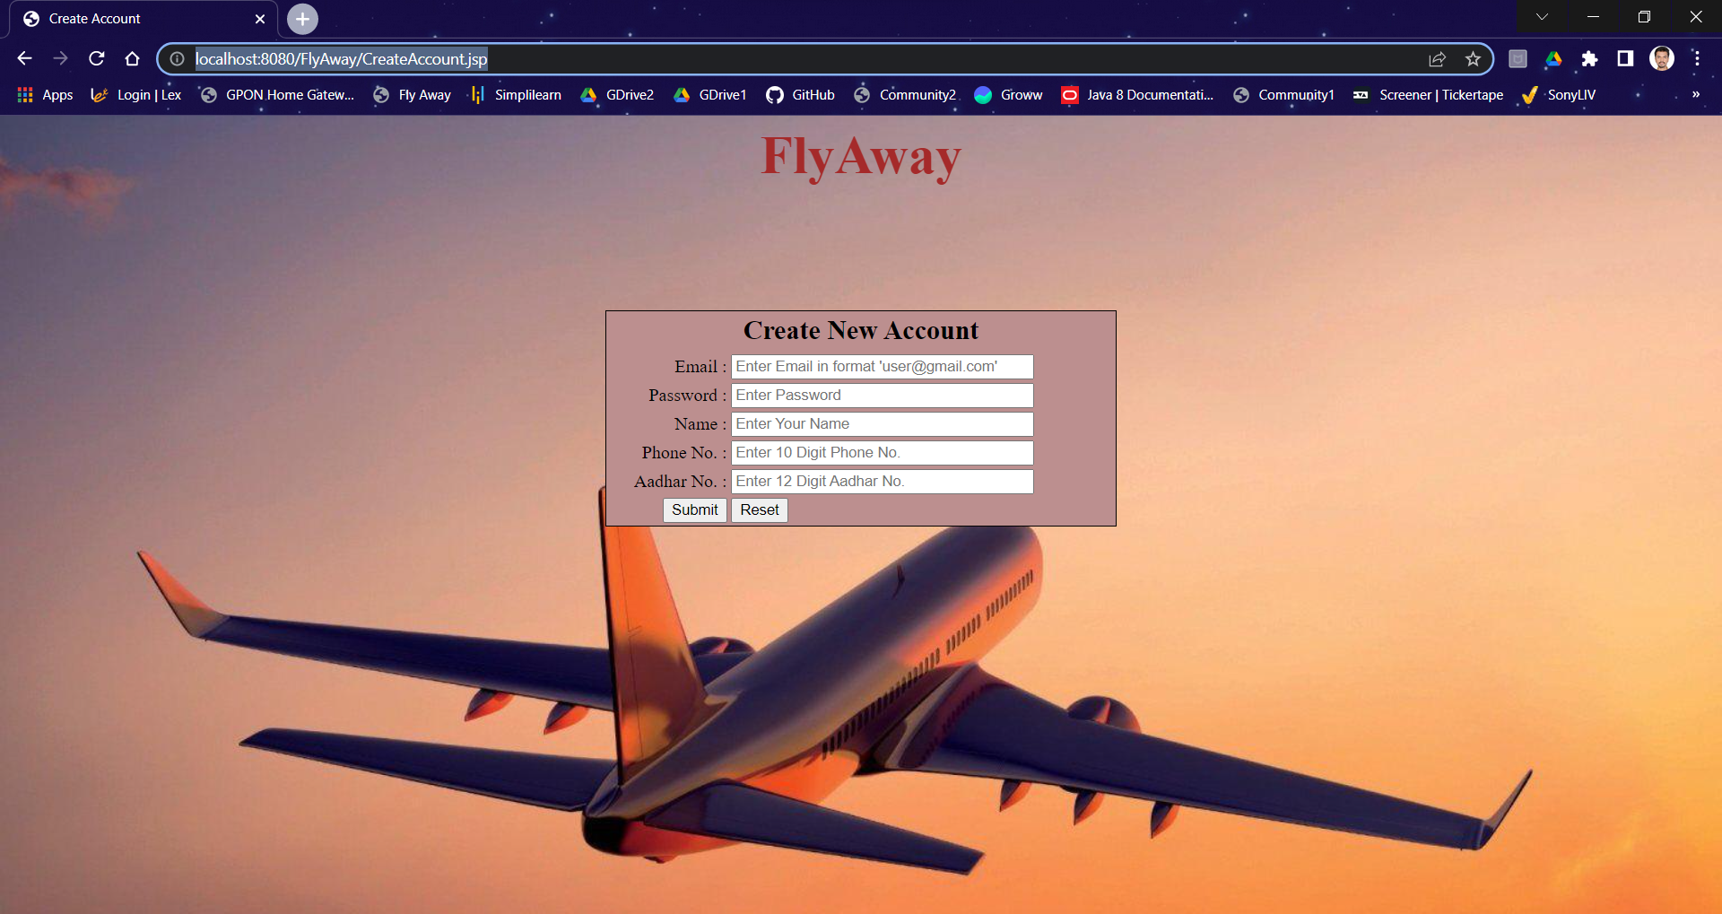

**On Successful Account Creation**

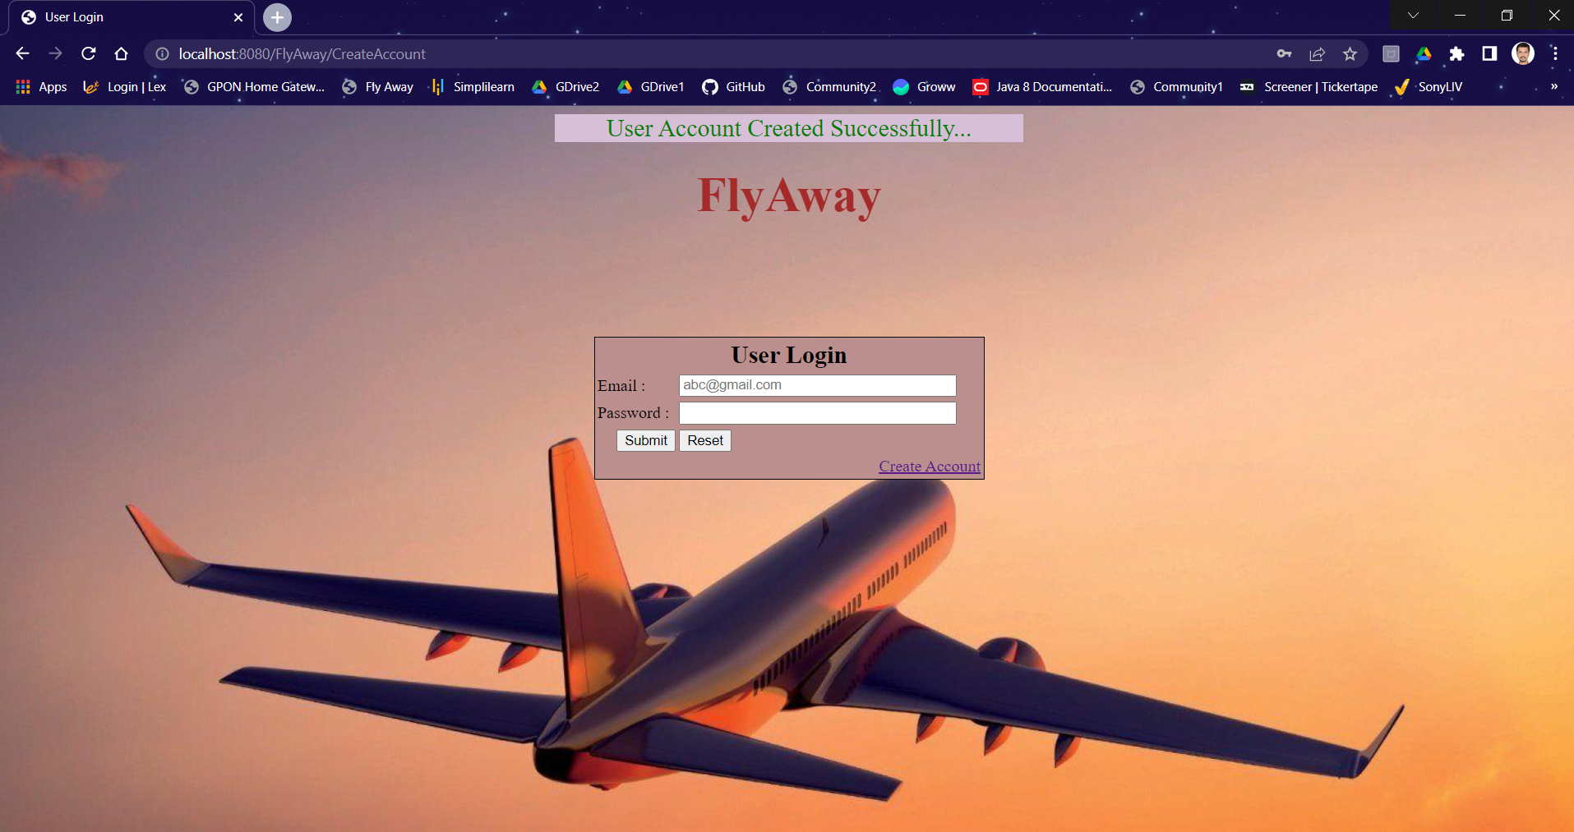

**On Unsuccessful Account Creation**

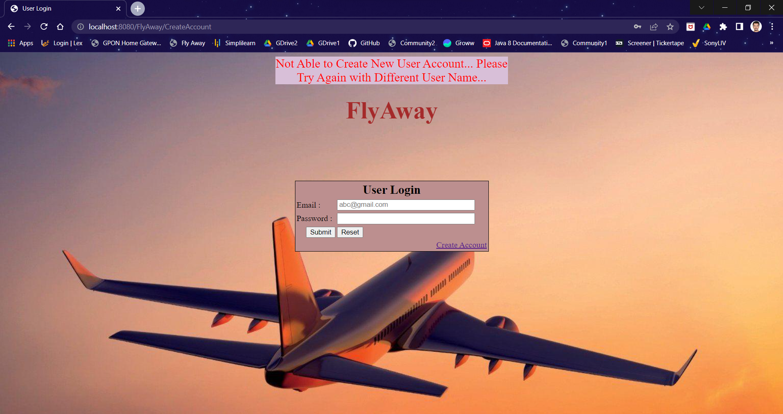

1. **Login Functionality**

**URL:** [**http://localhost:8080/FlyAway/UserLogin.jsp**](http://localhost:8080/FlyAway/UserLogin.jsp)

**On Successful Login**

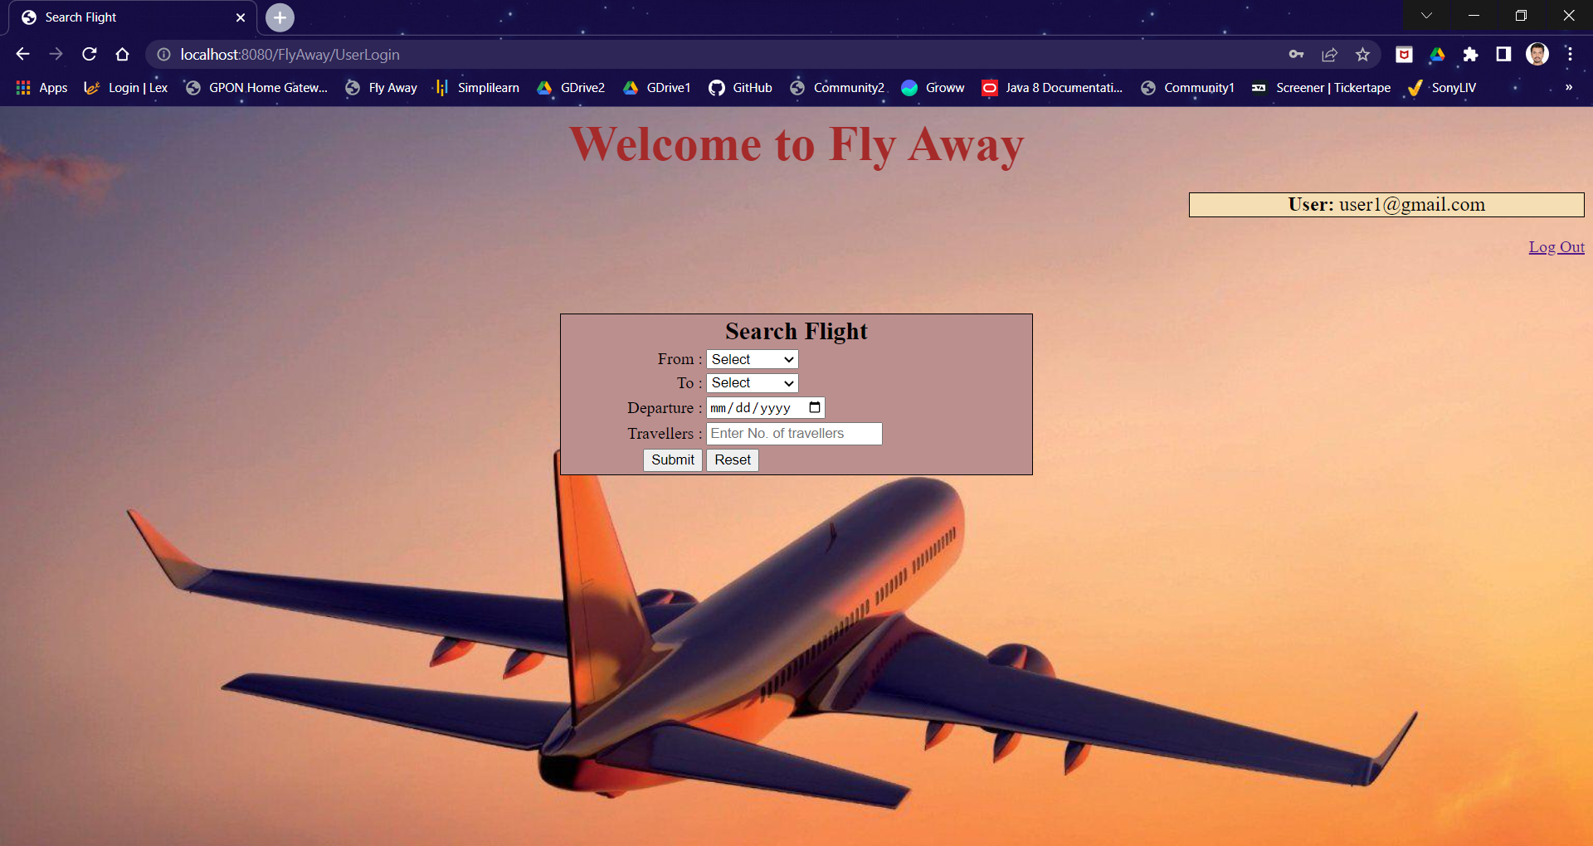

**In Case of Login Failure**

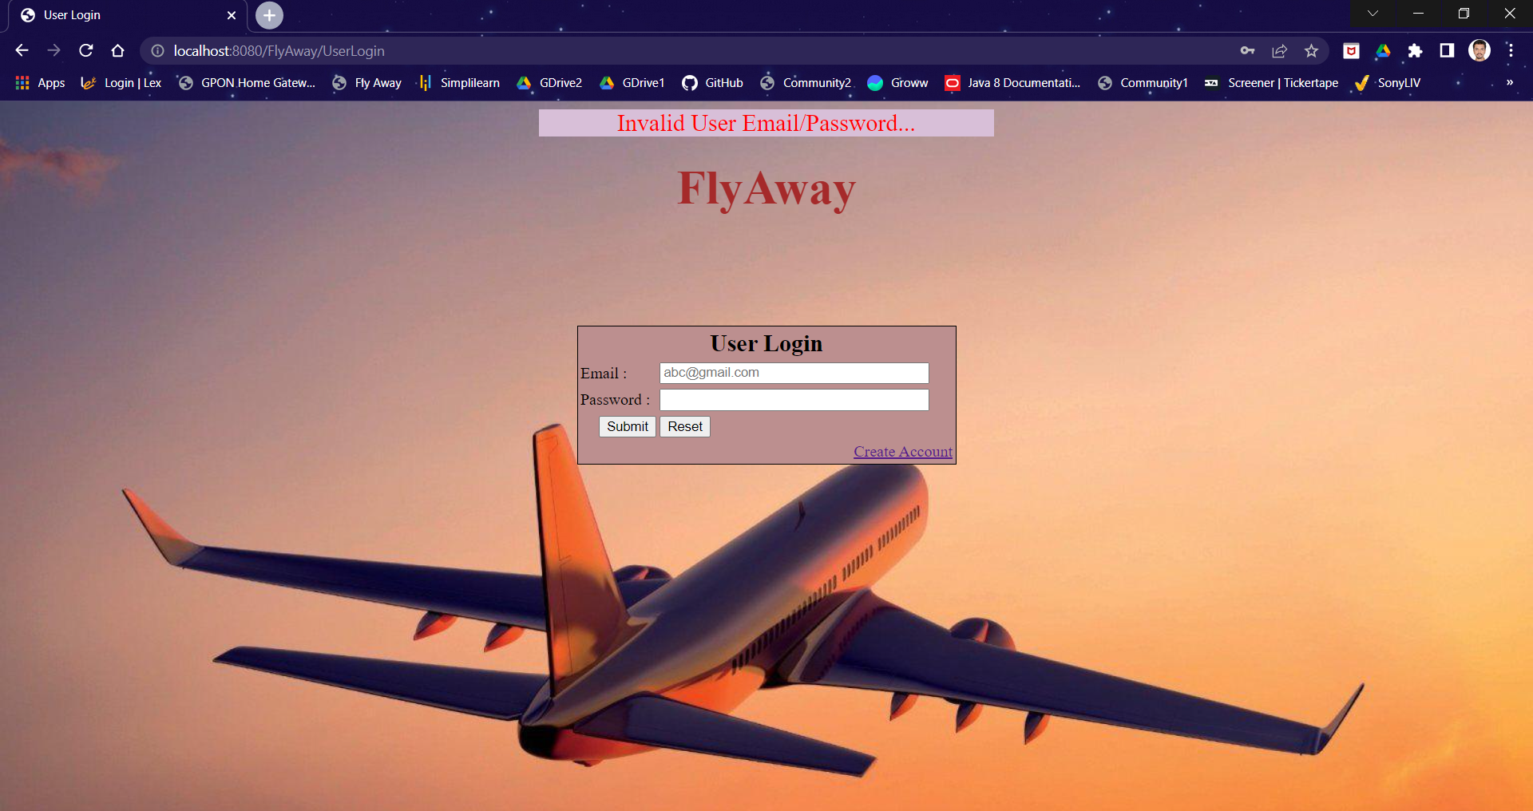

1. **Flight Search Functionality**

**URL:** [**http://localhost:8080/FlyAway/SearchFlight.jsp**](http://localhost:8080/FlyAway/SearchFlight.jsp)

**Flights Available Case**

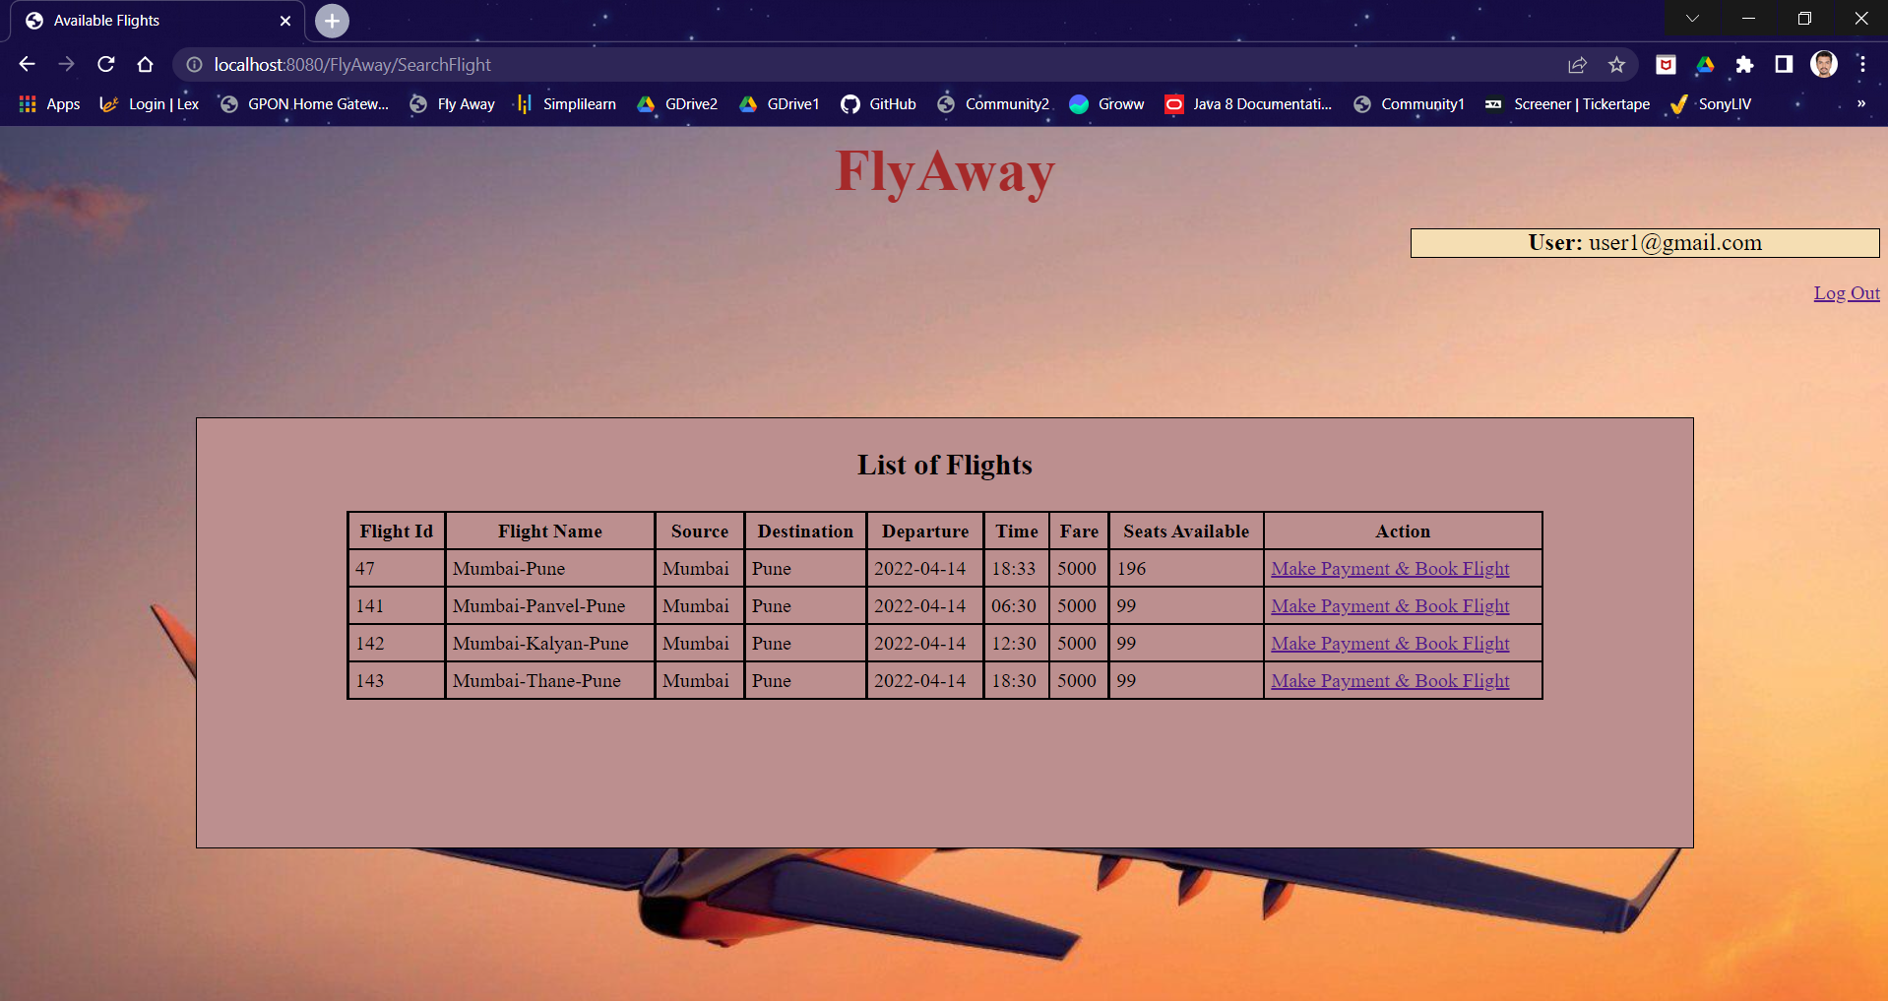

**Flights Not Available Case**

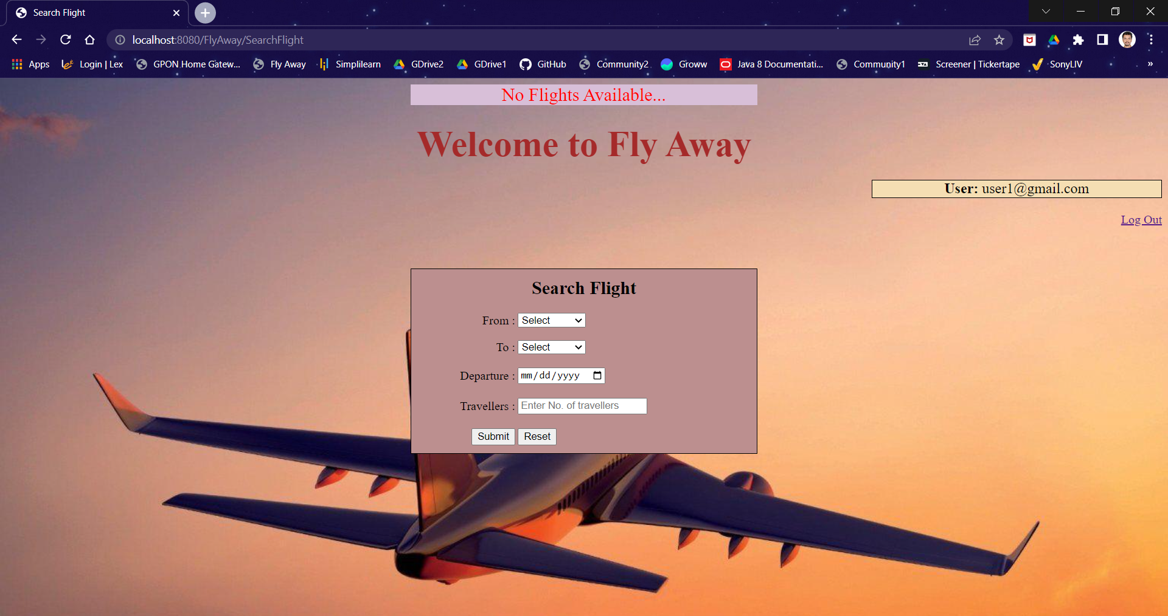

1. **Flight Booking Functionality**

**URL:** [**http://localhost:8080/FlyAway/FlightBooking.jsp**](http://localhost:8080/FlyAway/FlightBooking.jsp)

**On Successful Flight Booking**

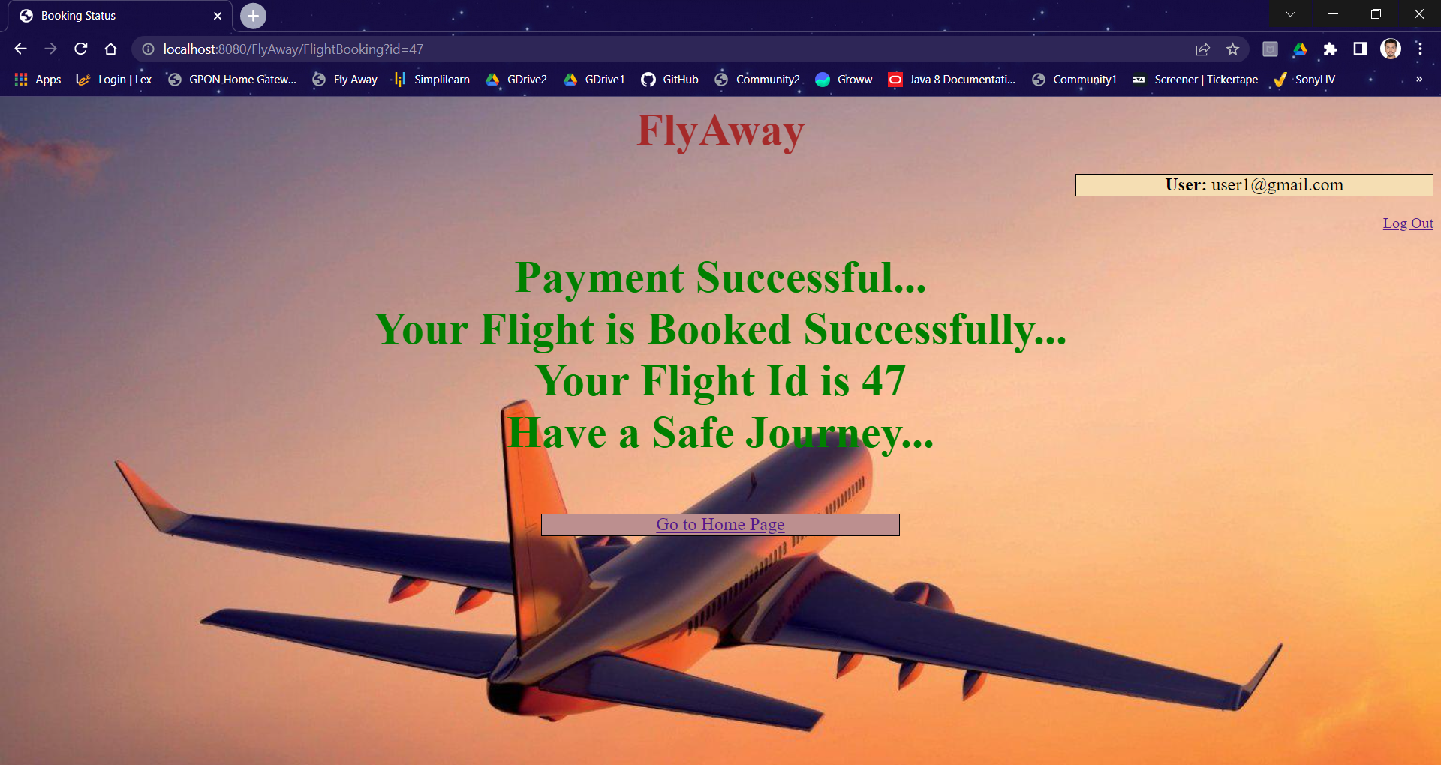

**On Unsuccessful Flight Booking**

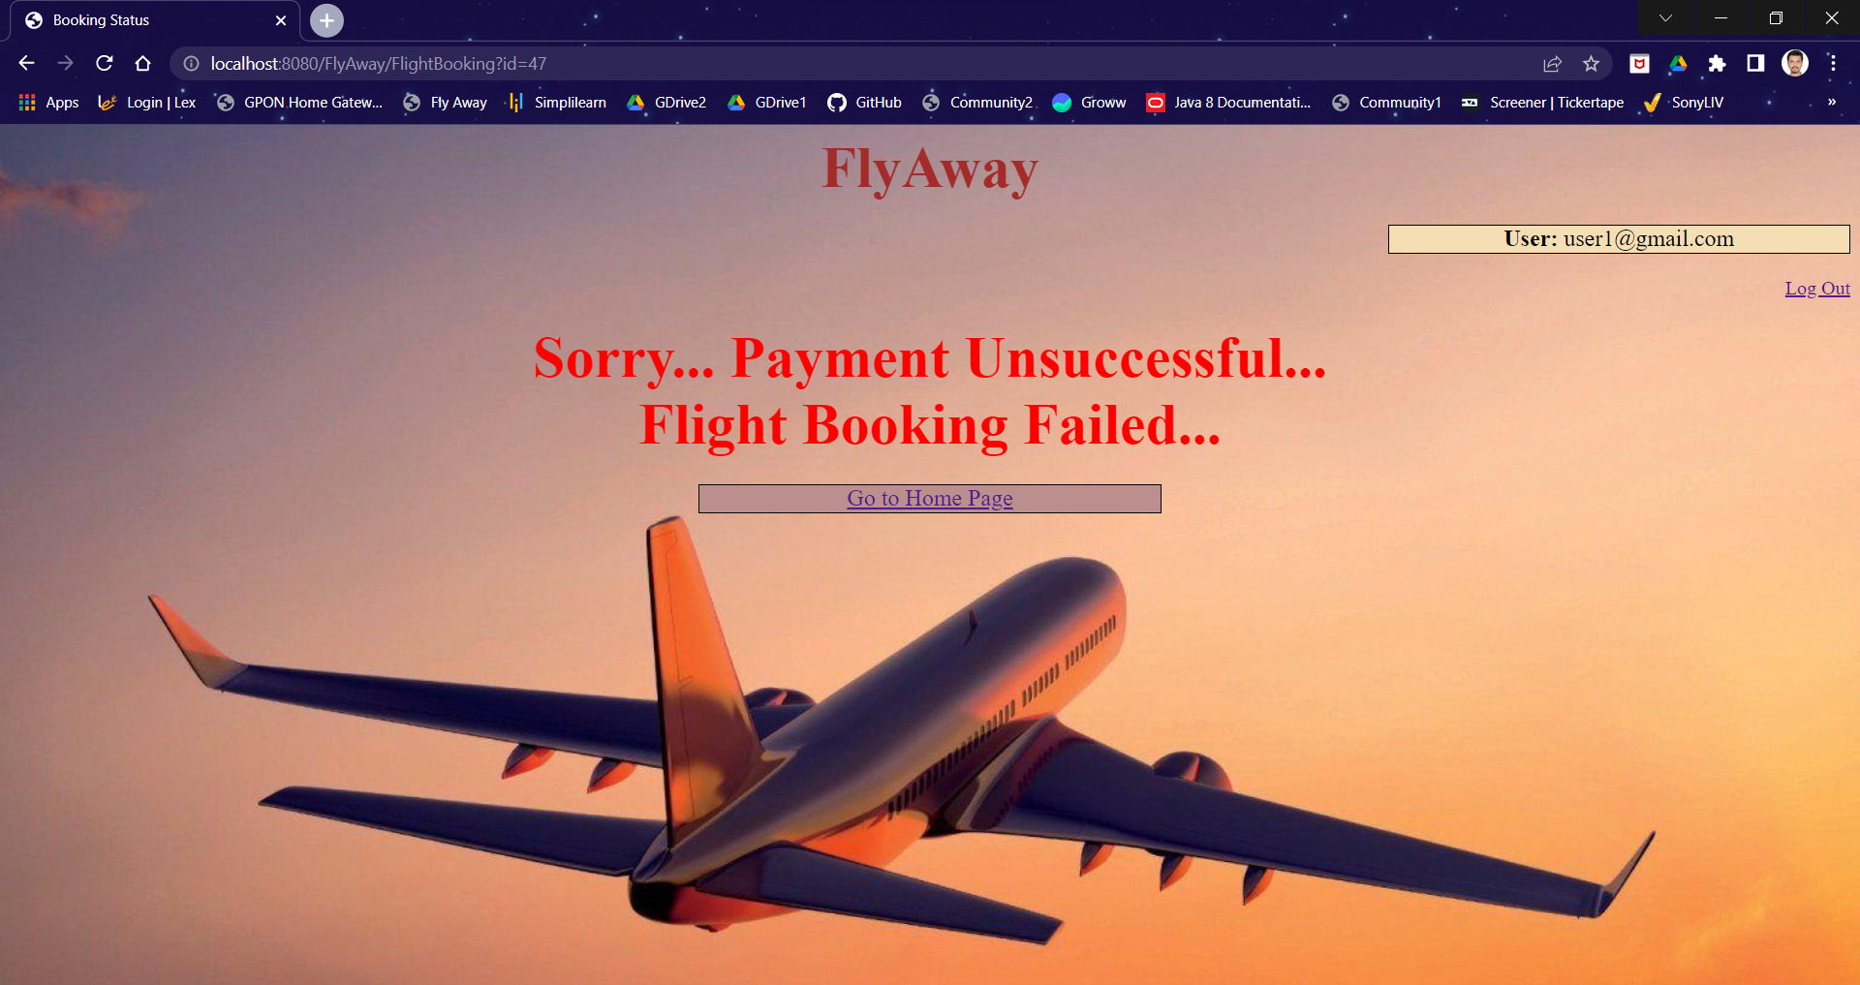

1. **Log Out Functionality**

**URL:** <http://localhost:8080/FlyAway/LogOut.jsp>

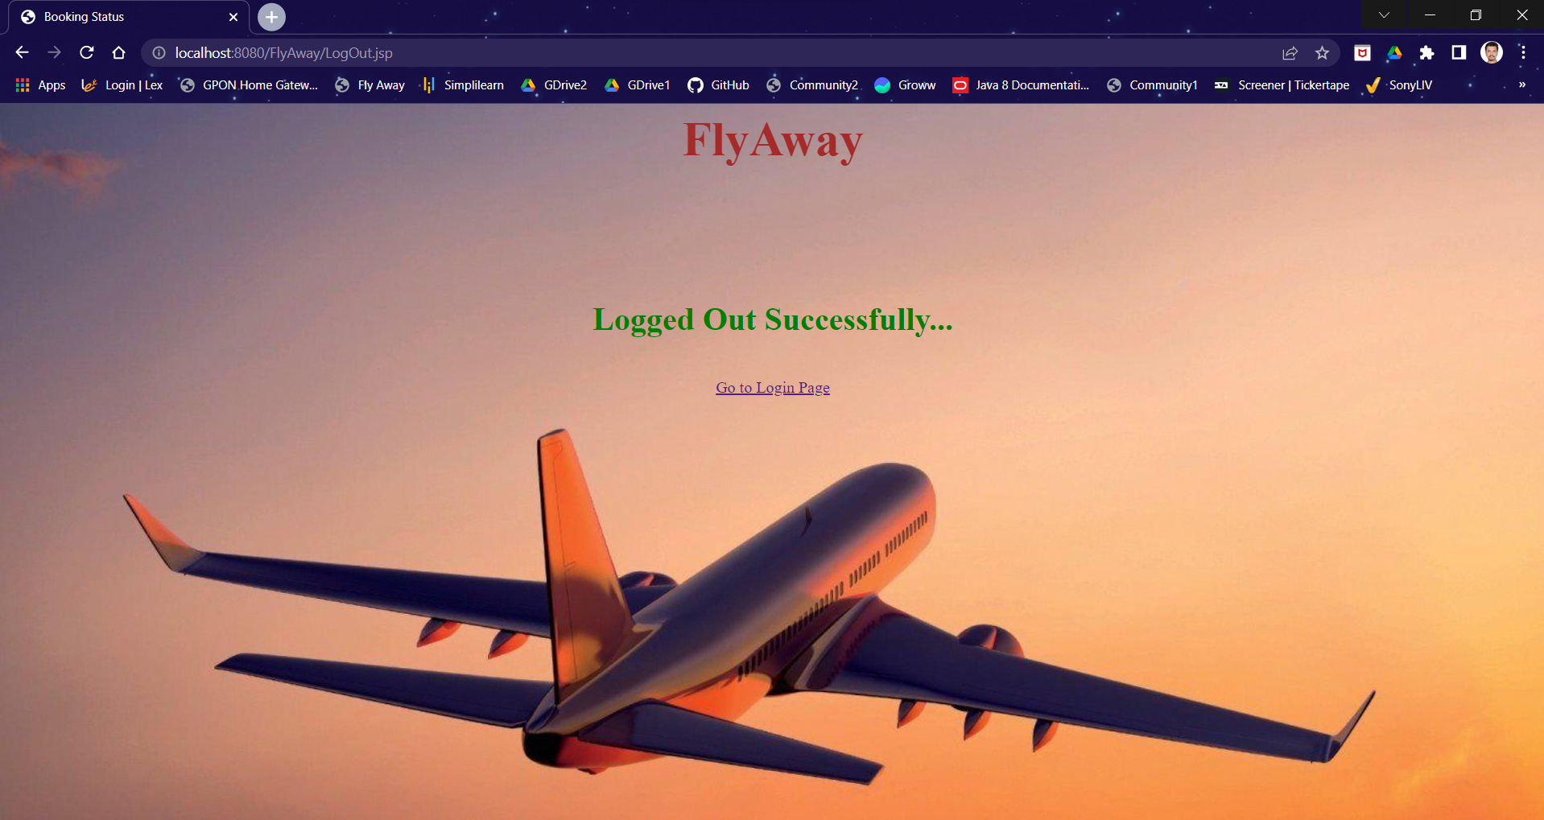

1. **Login as Admin**

**URL:** <http://localhost:8080/FlyAway/AdminLogin.jsp>

1. **Login Functionality**

**Admin Login Page**

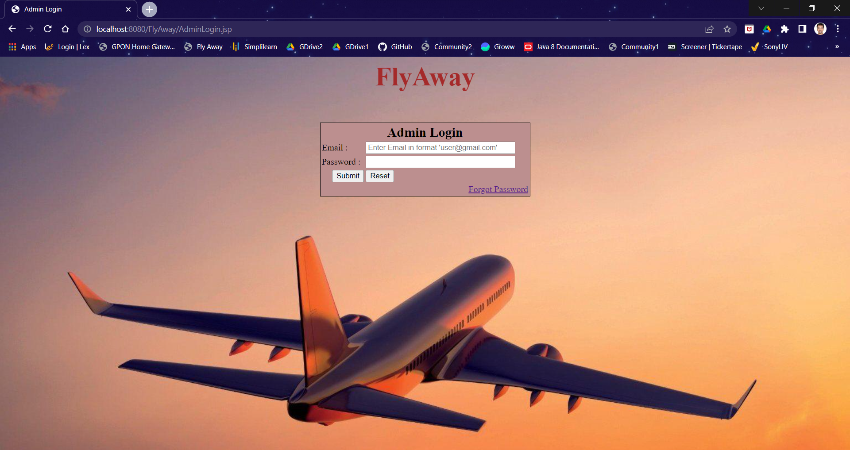

**On Successful Login**

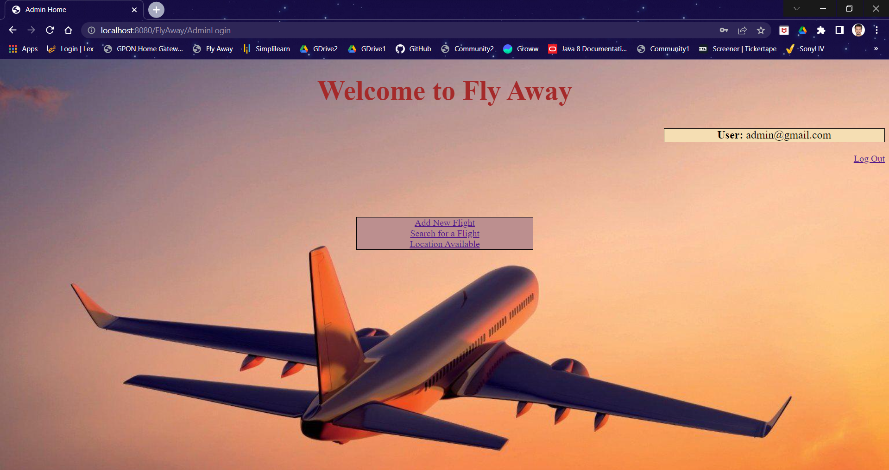

**In Case of Login Failure**

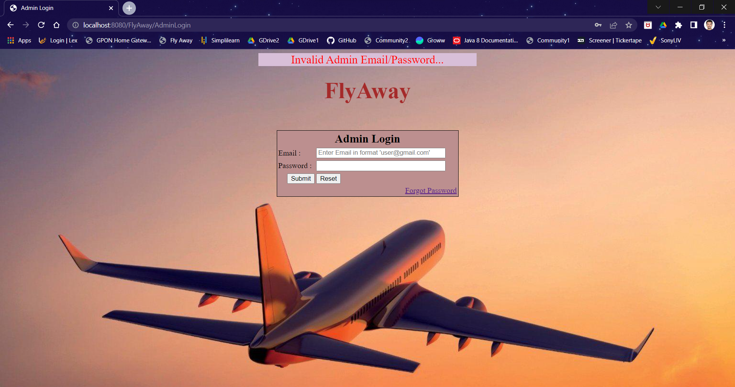

1. **Password Reset Functionality**

**URL:** <http://localhost:8080/FlyAway/PasswordReset.jsp>

**Password Reset Page**

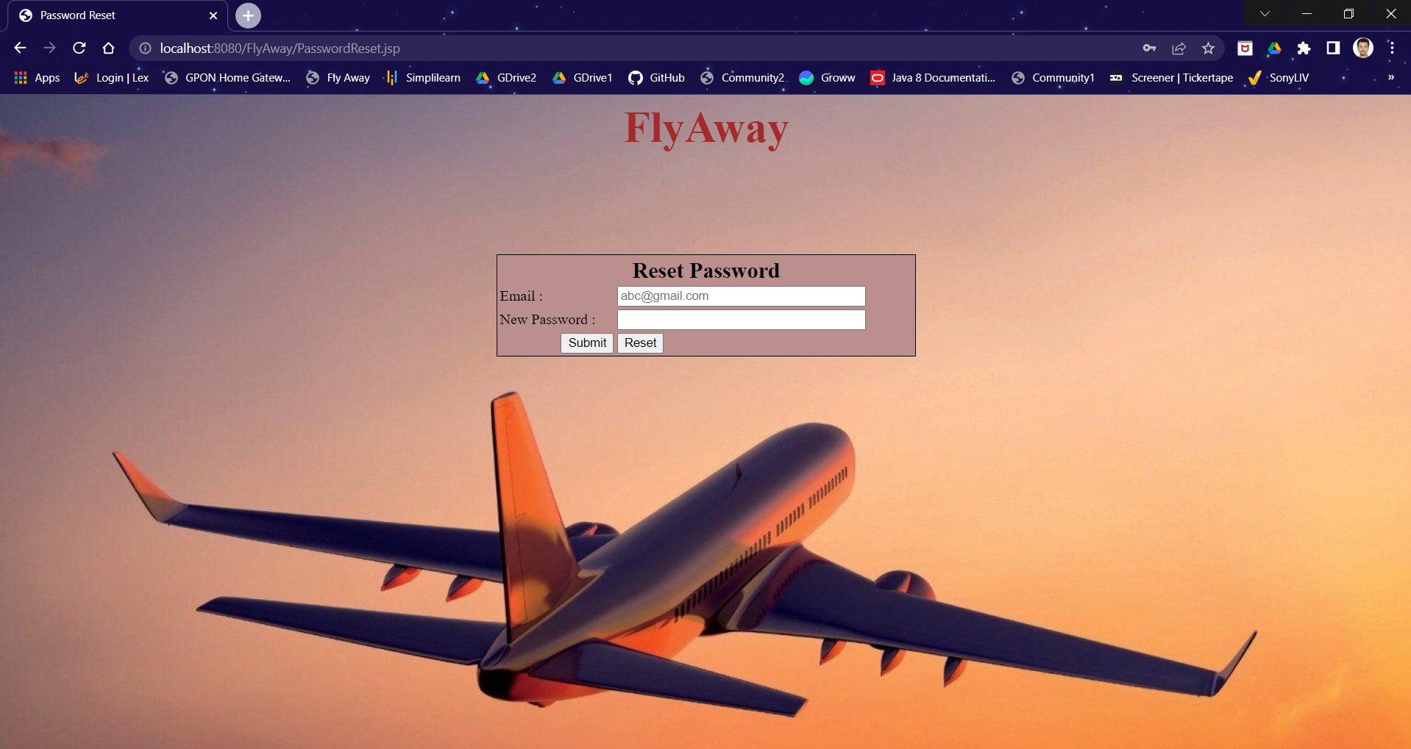

**On Successful Password Reset**

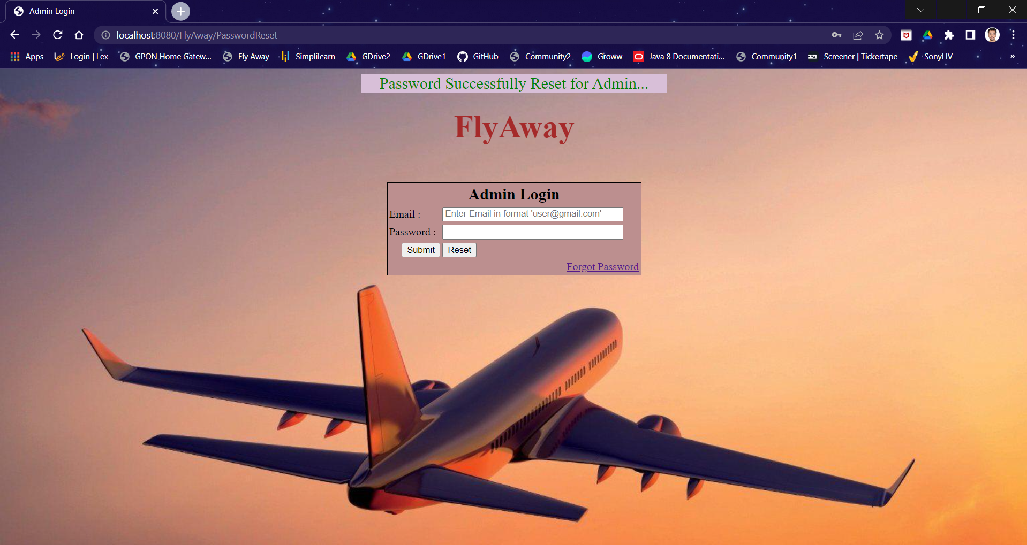

**On Unsuccessful Password Reset**

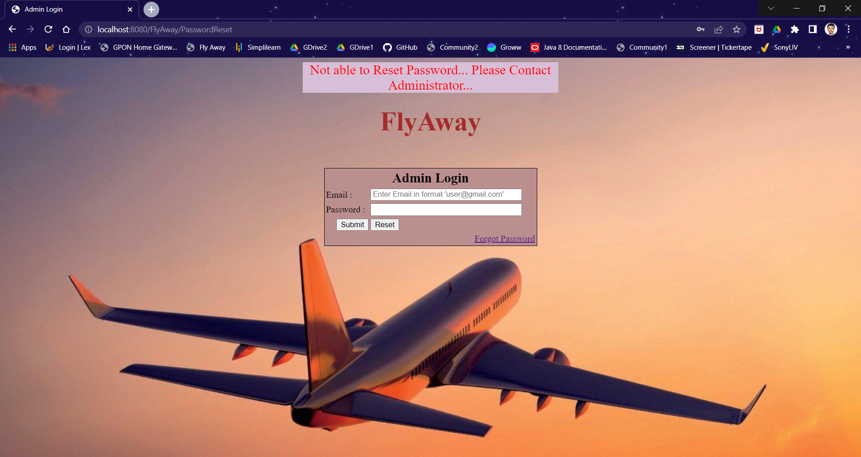

1. **Flight Search Functionality**

**URL:** [**http://localhost:8080/FlyAway/SearchFlight.jsp**](http://localhost:8080/FlyAway/SearchFlight.jsp)

**Search Flight Page**

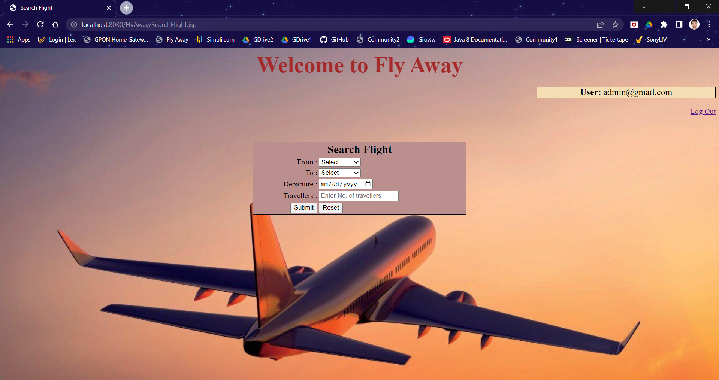

**Flights Available Case**

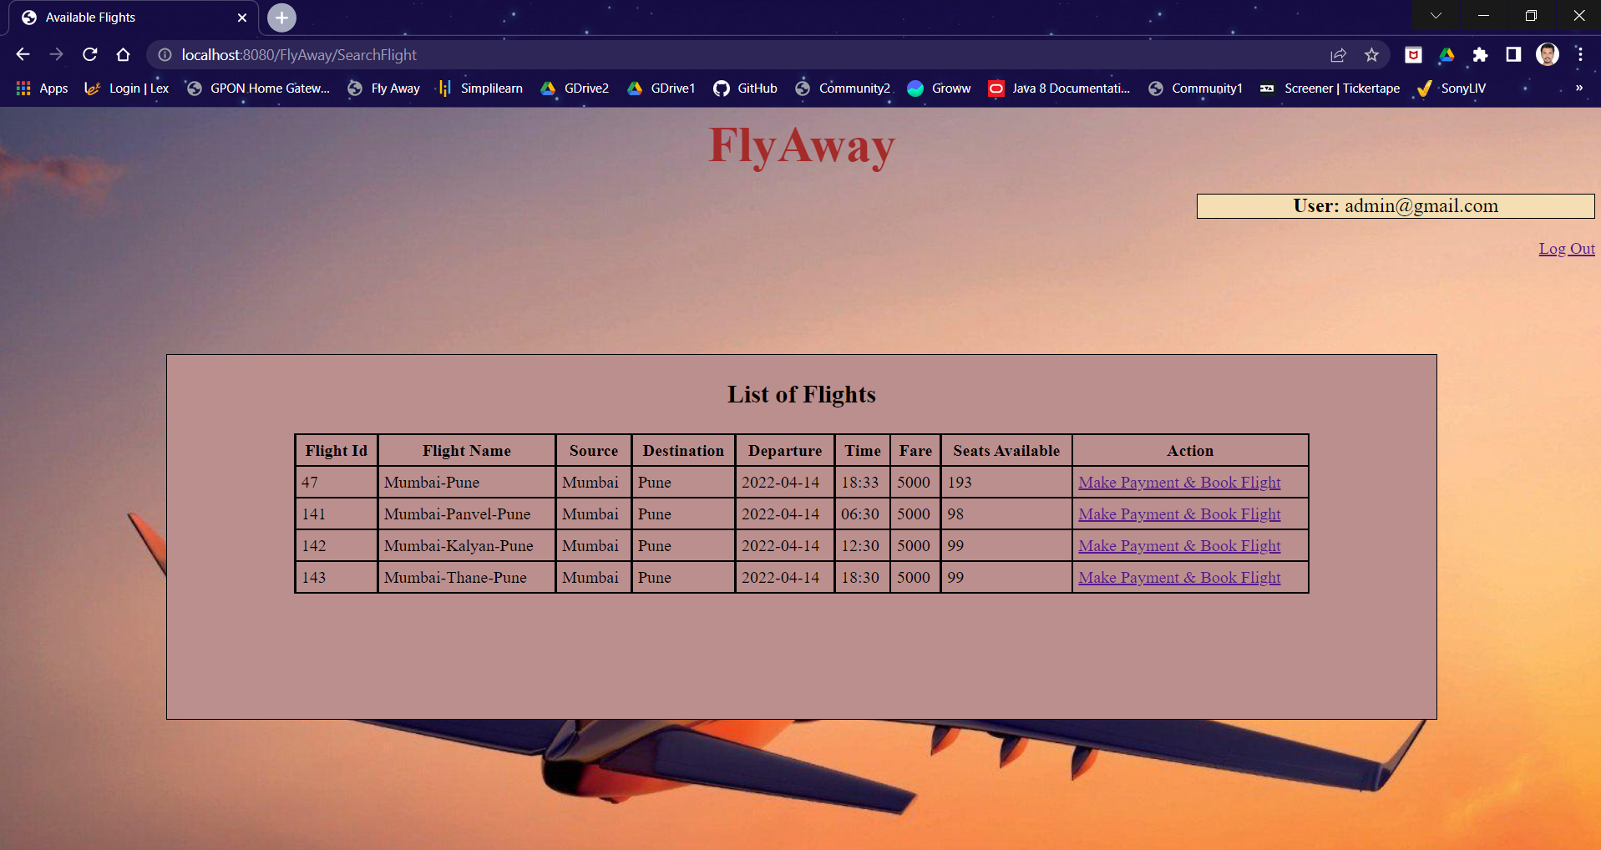

**Flights Not Available Case**

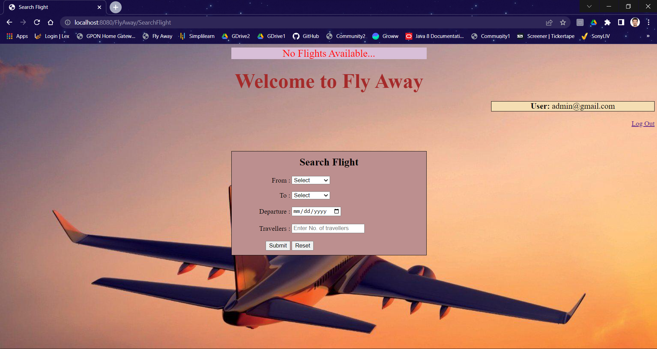

**IV. Flight Booking Functionality**

**URL:** [**http://localhost:8080/FlyAway/FlightBooking.jsp**](http://localhost:8080/FlyAway/FlightBooking.jsp)

**On Successful Flight Booking**

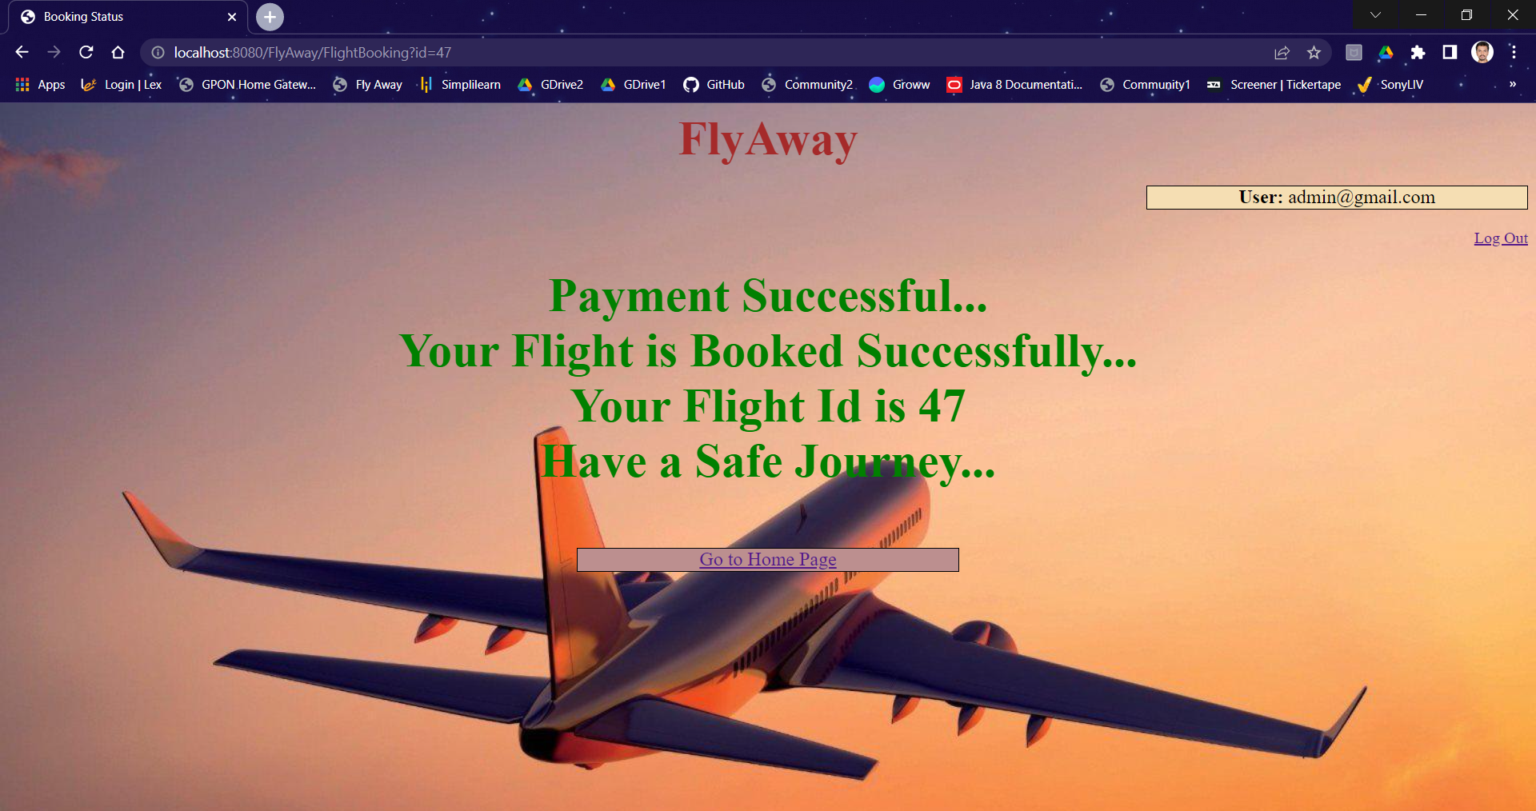

**On unsuccessful Flight Booking**

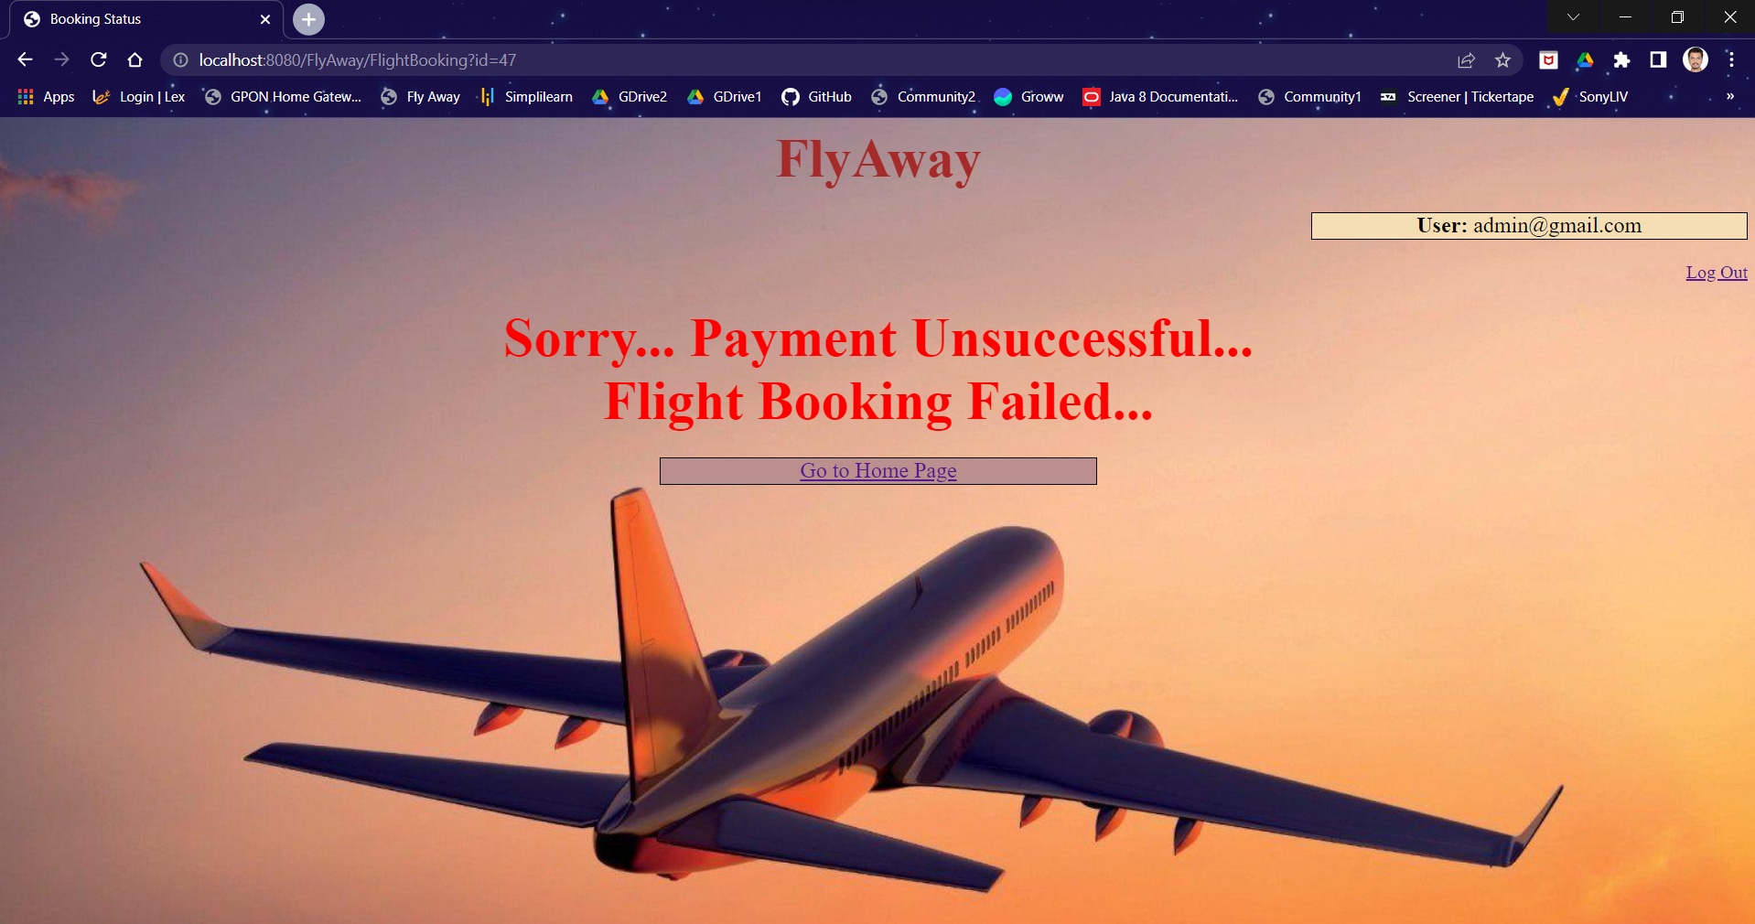

**V. Adding New Flight Functionality**

**URL:** <http://localhost:8080/FlyAway/NewFlight.jsp>

**Insert New Flight Page**

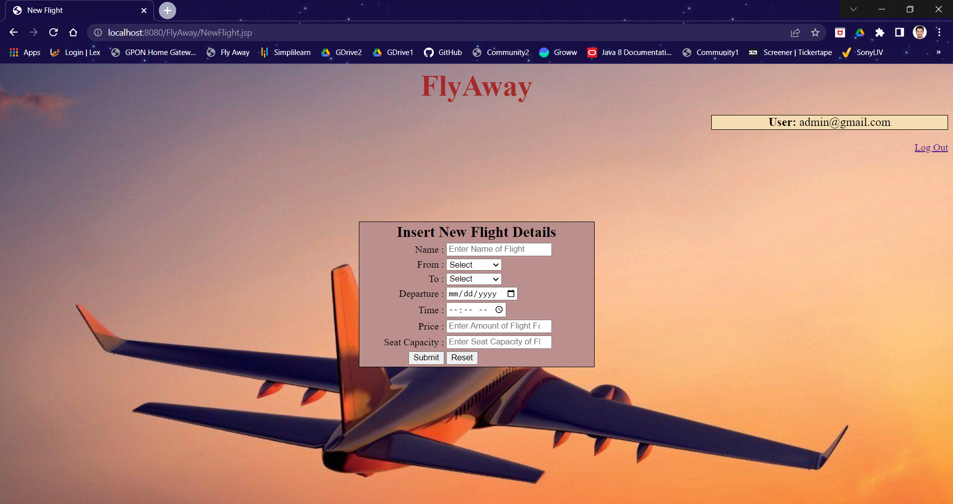

**Successful Insertion of Flight**

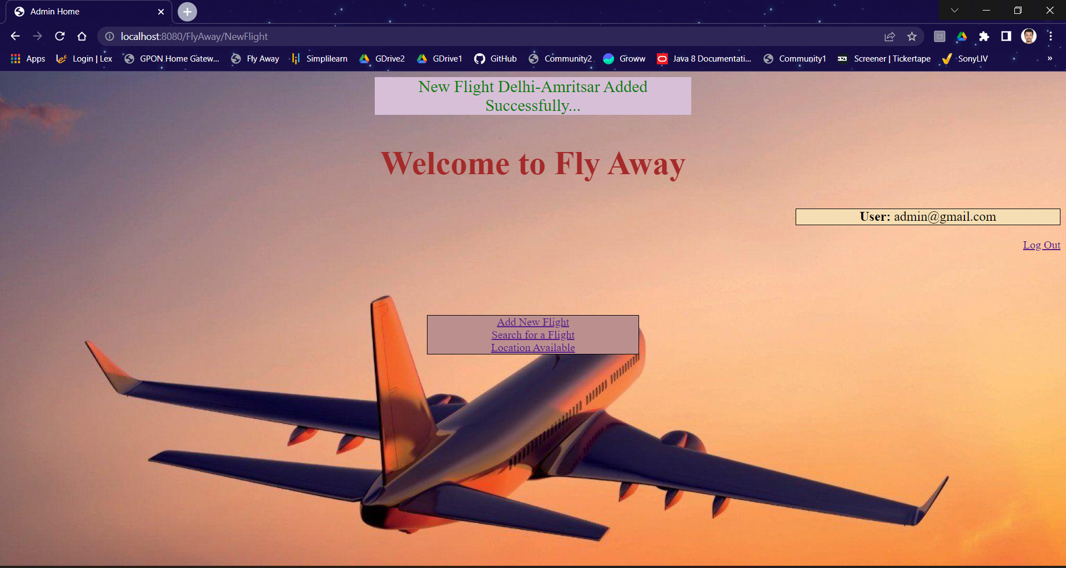

**Unsuccessful Insertion of Flight**

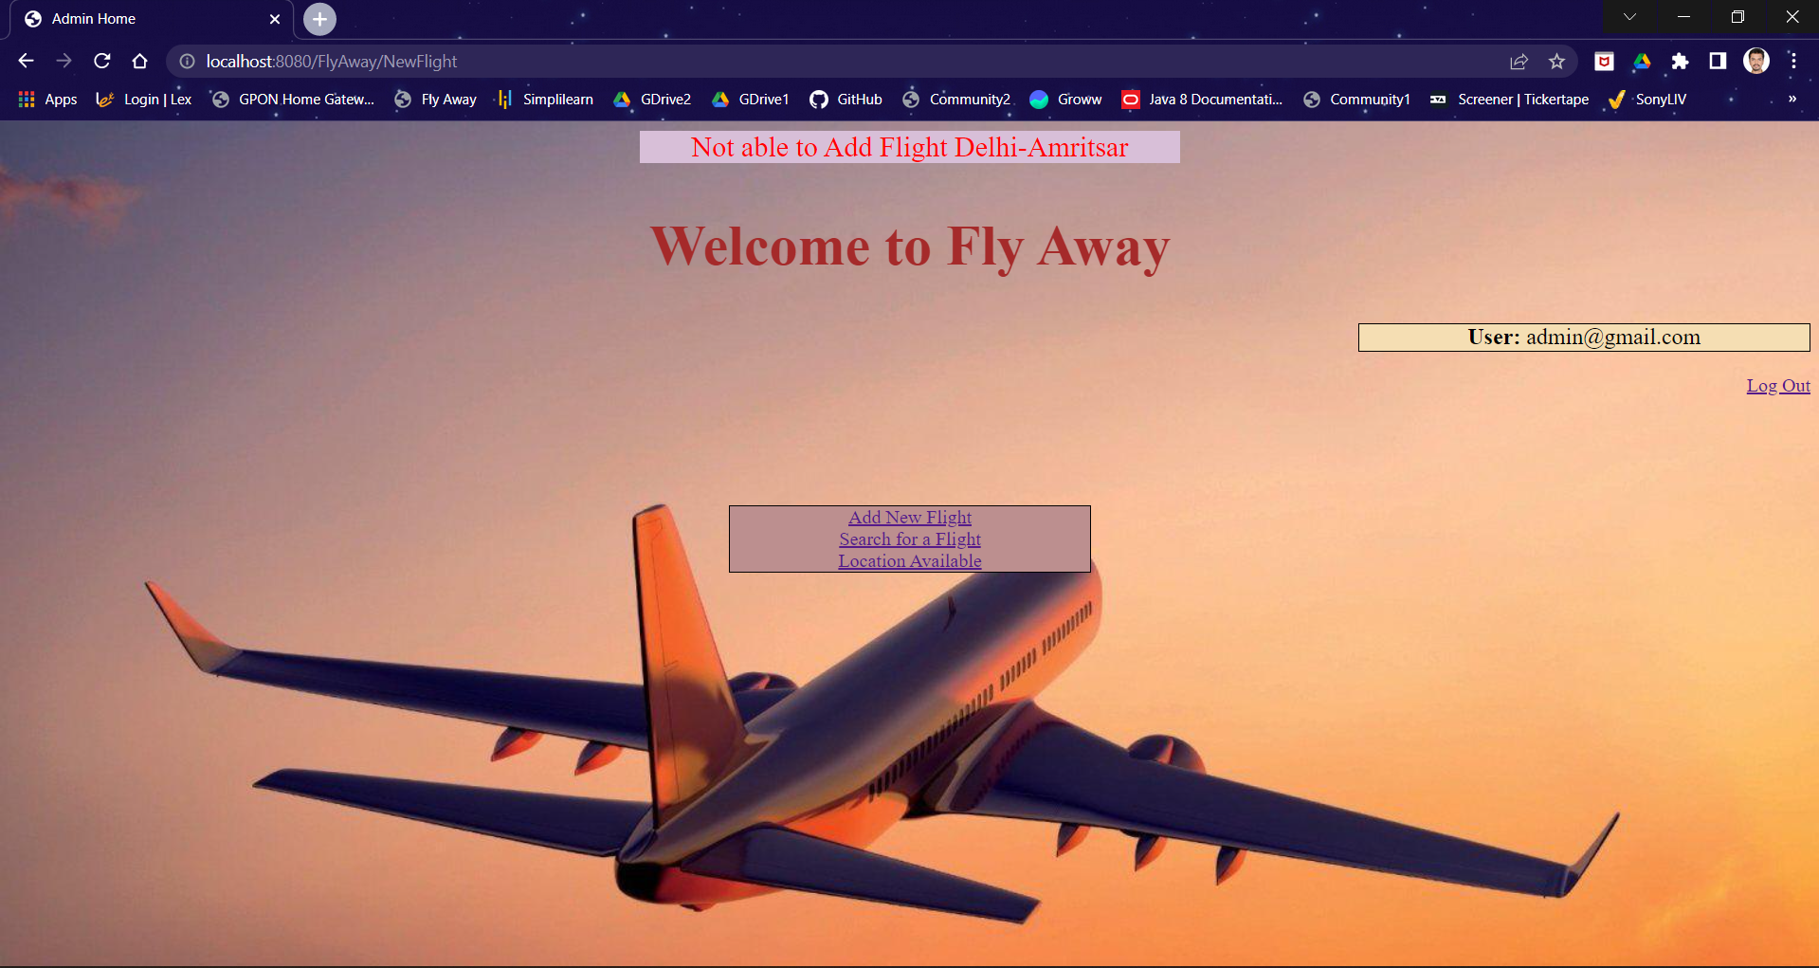

**VI. All Available Locations Functionality**

**URL:** <http://localhost:8080/FlyAway/Location.jsp>

**Locations**

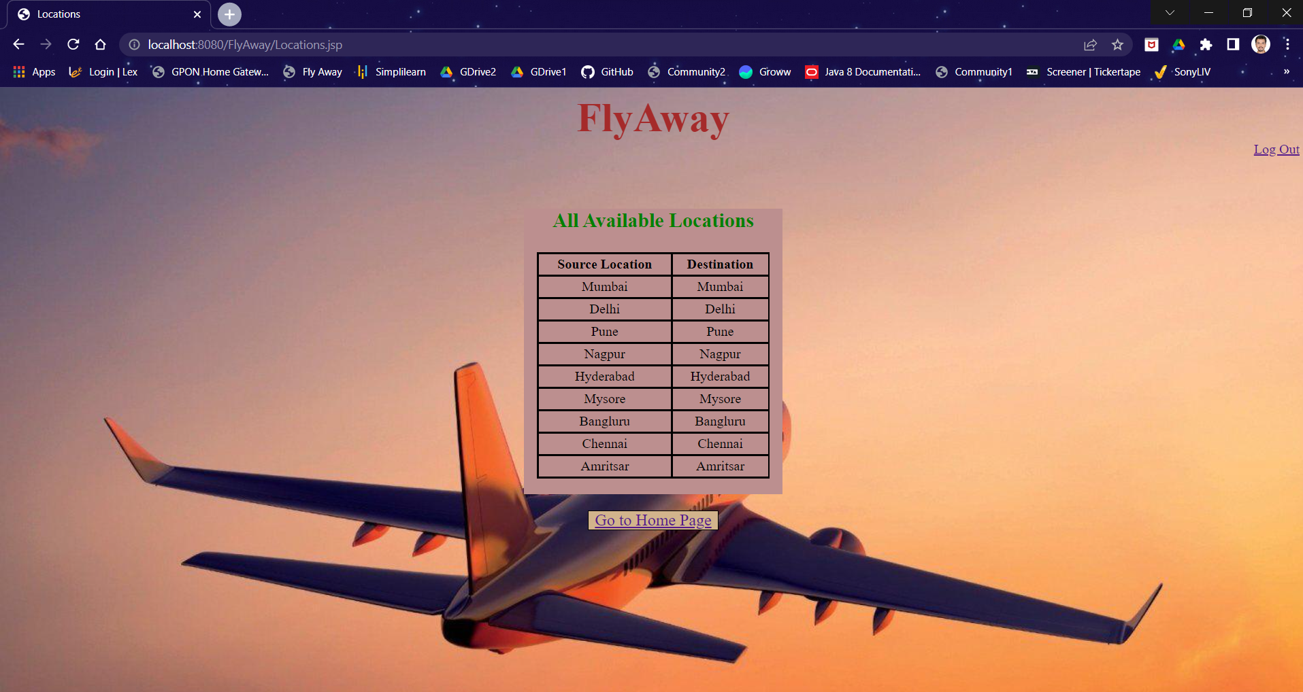

**VII. All Available Flights & Delete Flight Functionality**

**URL:** <http://localhost:8080/FlyAway/ViewAvailableFlights.jsp>

**Displaying All Available Flights**

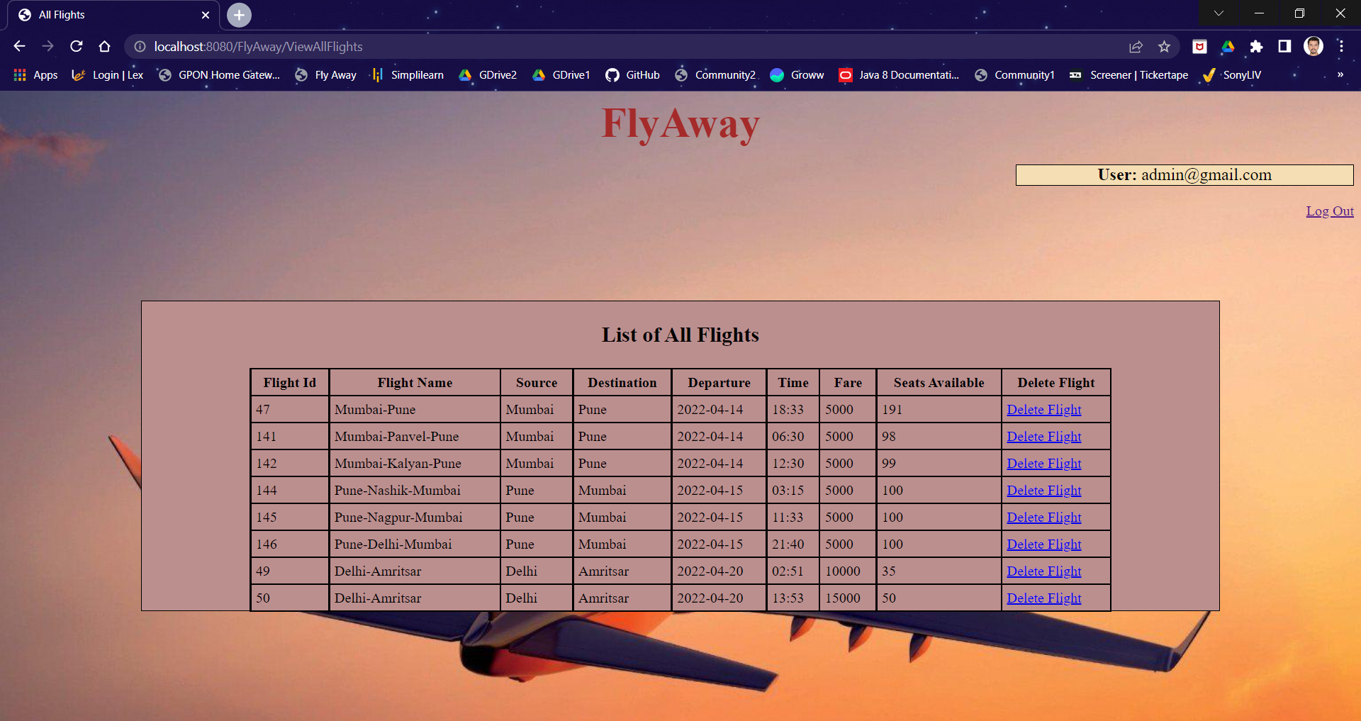

**Successful Deletion of Flight**

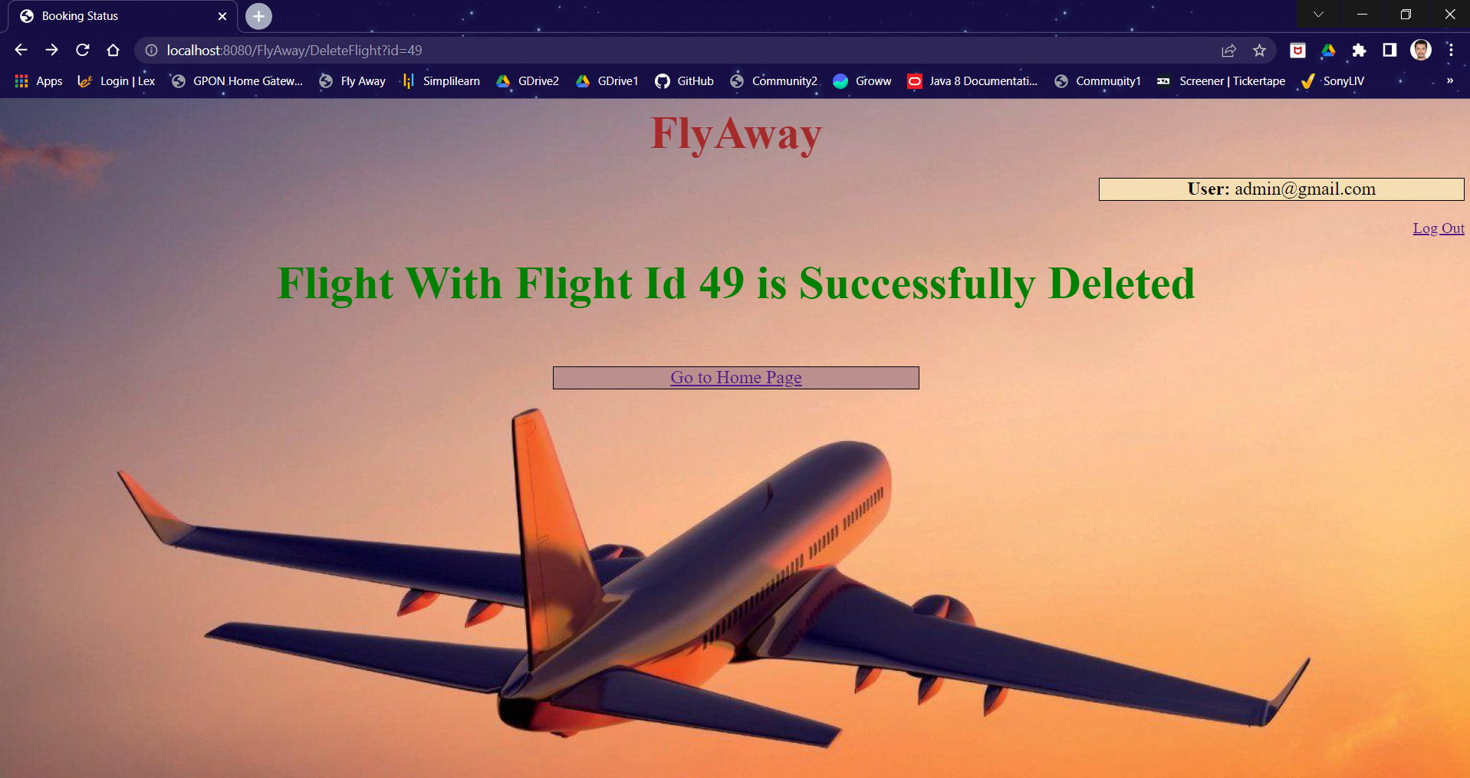

**Unsuccessful Deletion of Flight**

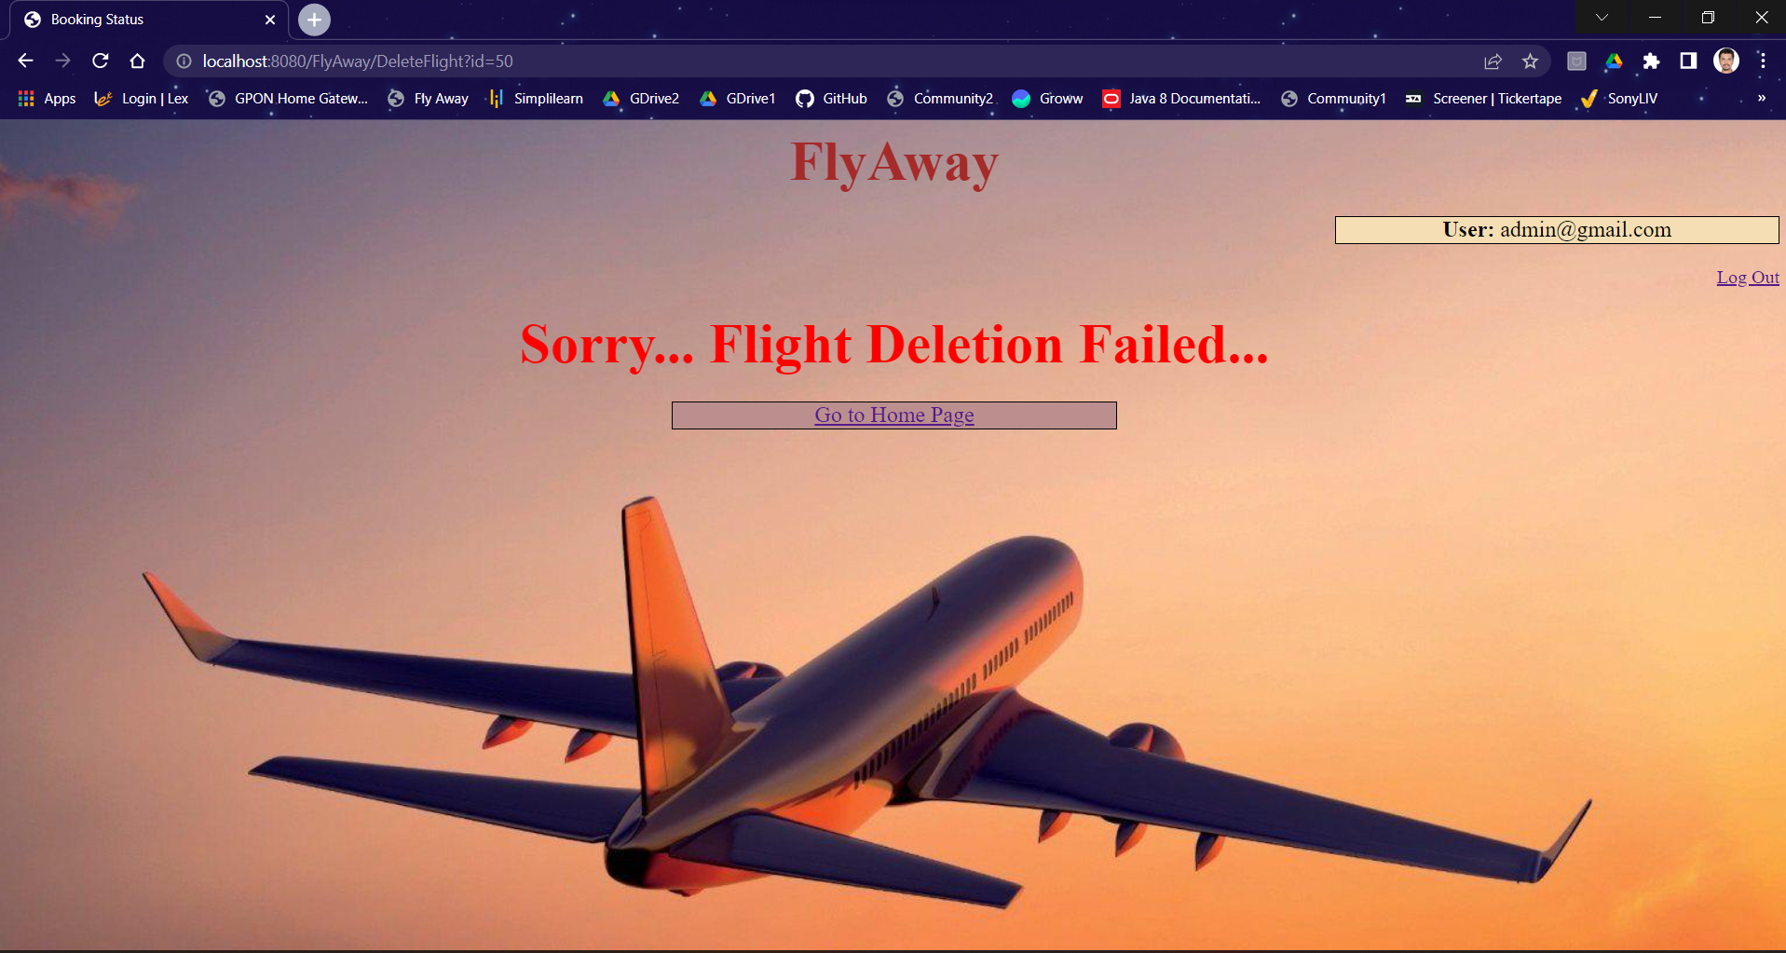

**VII. Log Out Functionality**

**URL:** <http://localhost:8080/FlyAway/LogOut.jsp>

**Log Out Page**

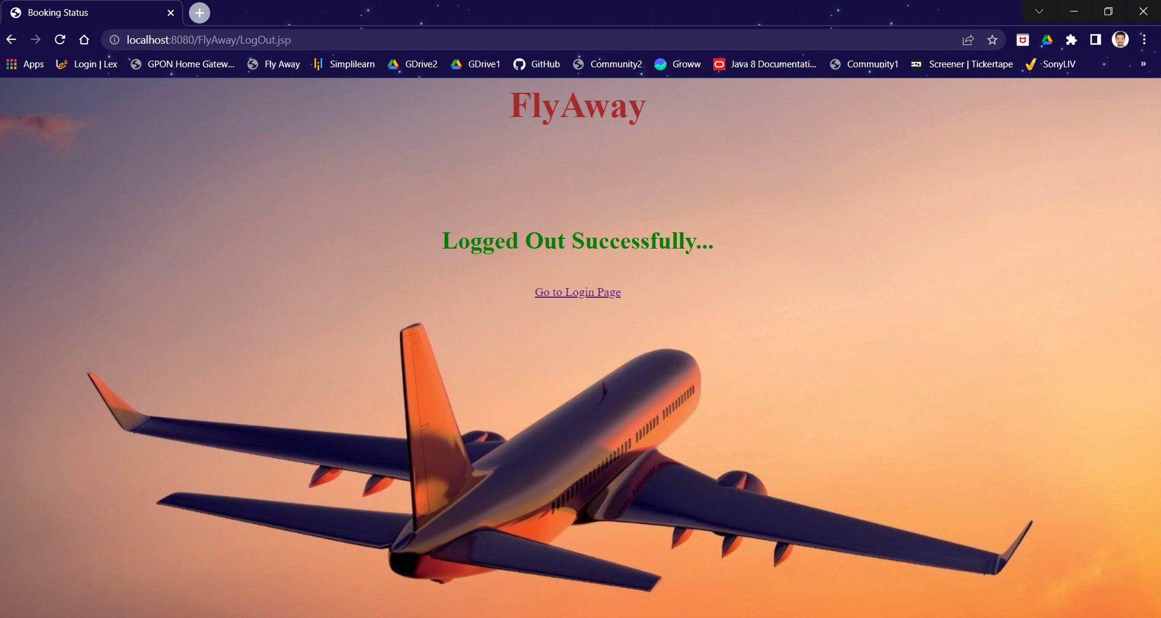

**6. Links to the GitHub Repository & Notes**

1. **Link:**
2. **Note:**
3. Code present in master branch
4. Admin email should be [admin@gmail.com](mailto:admin@gmail.com) only. Which will not change in any condition and respective Insert statement is available in below attached Database.sql file.
5. Before Running Web Application, please execute below Database.sql file in SQL DB.



1. Please configure database details in hibernate.cfg.xml file present in /FlyAway/src/main/java/hibernate.cfg.xml

**7. Your conclusion on enhancing the application and defining the USPs (Unique Selling Points)**

1. **Enhancements –**

* Functionality for Admin to Updated flights details.
* Functionality for User to View previous bookings.

1. **Unique Selling Points (USP)**

* User Friendly Application
* Versatile and Scalable